|  |
| --- |
| British University in Egypt (BUE) – The IG Club**Yr4-Mechanical Engineering**  **semester 1 (21/22)** |
| Self Balancing Robot |
| Applied Microcontroller Prog.MECH83H |
| Module leader: Dr. Mahmoud Magdy  Module TA: Eng. Omar El-mergawy  Student Name: Kareem Nabil Hamed  Student ID : 167042 |
|  |
| WhatsApp Image 2022-01-30 at 11.29.45 PM.jpeg |

Contents

Table of figures 2

Introduction 3

Background 3

PID controller 4

Description 5

Arduino UNo 6

MPU6050 7

H-bridge 8

H-bridge connection 9

Dc Motors 10

Ultasonic sensor 10

Bluetooth Module 11

Alkaline Battery 11

Lithiuom ion battery 12

Robot Frame 12

Mechanical Drawing (SW) 13

electical Drawing 18

Block Diagram 20

Flowchart 21

Direction Flowchart 22

Structure Analysis 23

Free Body Diagram 24

Simulation result 25

Self balance robot code 30

Datasheet 35

Refrences 37

Refrence vidoes :

https://drive.google.com/drive/folders/1gYx0iPUm8mC_k_86rmCqq3NL6ZC79C_e?usp=sharing

**Table of figures**

Figure 1:inverted pendulam 3

Figure 2: PID controller 4

Figure 3: PWM Wave 5

Figure 4:Arduino Uno 6

Figure 5:Mpu6050 7

Figure6:H-bridge 8

Figure7 Dc motors 10

Figure8:Ultrasonic sensor 10

Figure 9: Bluetooth module HC-05 11

Figure 10: 9-volt Alkaline 11

Figure 11: lithium ion rechargeable battery 12

Figure 12 robot frame: 12

Figure 13: I2C fast mode frequency 35

Figure 14: I2C modes 35

Figure 15: Interupt states of mpu6050 36

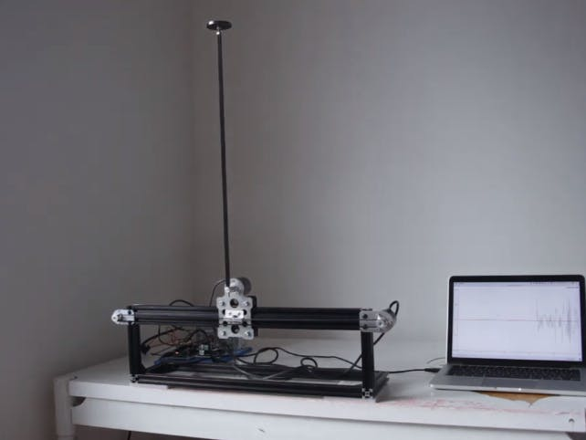

Figure Ref 2Inverted Pendulam

* Introduction

Design and technique in conducting selfbalancing robot is the same as balancing inverted pendulum. Inverted pendullam may be basic problem and concept in dynamics life. Inverted pendullam is used wordly to test control algorithms (PID variable, neural networks and genetic algorithms)( ). Rockets or Missile are a simple example for inverted pendullam. Where their center of gravity should always be located in the center. This phonemina can be explained using self balance robot.

* Background

Self balance robot is the solution for inverted pendulum problem(). The purse of the loops is to control the wheels position, such that the angle of inclination should always be stable at fixed angle which is the anglewhen the robot is vertical or fixed. In case of the robot is falling in any direction, the wheels should move faster in the same direction of falling to decrease the angle of inclination.

For example, if the robot is falling forward, the motors will rotates in the same direction of falling to make the robot vertical in no time. Same happens when mentioning the rate of deviation. If the robot is deflecting by small angle, the motors will rotate is small speed to reach equibrium position and vise versa. Handling the robot to not fall in one direction may also cause problem when holding it, it might start falling in the other direction due to the converted mass from the other direction. Here comes the function of PID controllers.

PID (proportional, Integral, derivative) respectively are controller variables used to control any system or applications to a certain function as (speed, room temperature or self balance robot). PID is a controlled loop to handle and to control process vaules. These values should be very accureate ans stable to atcheieve the desired output.

* P controller

This controller is proportional to the state value of the error. It case the error is big and positive, the p controller will control the output value to be large and positive. Using P controller only will result in errors that is set between actual values and setpoint. P controller needs error to establish proportional act. It case of zero error, there will be no corrective responed.

* I controller

I controller states for the prevoius value which intergartes these values over time to produce the I term. Such as, if the error in the P controller, the intergral interfernce to minimize this error by adding the I controller effect, which is collect from the prevoius loops of the errors. In case of the error vaniches, the I controller get to increase again.

* D controller

D controller is used to esimate the upcoming error that may accure. Depending on the current rate of deflection. D controller aims to minimize the error by understanding the rate of which error changes.

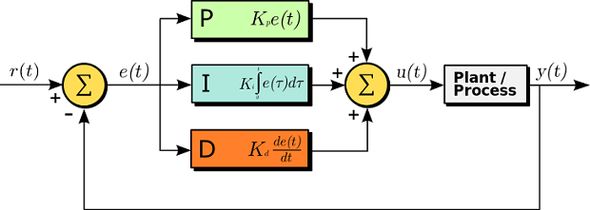

Figure Ref3. PID controller

* Description of the project

Self balance robot is derived from inverted pendullam. This aime to stay stable, in possion which its mass of gravity applied in the center achieving balance. This same concept applied for the self blanance robot. The balancing of the robot is etbalished using MPU6050 which measure the accelermotor and the gyroscope. MPU give order or signal to the Arduino board which recieves this data. Accrourding to the data, the Micro controller which is in this case Arduino UNO, will send signals to the motors to move and reach vertical motion (balance position) . the MPU will keep recieving signal and sending signals to maintane all the time balancing through the controlled controllers PID.

This Robot consists of many electrical components.

1. Microcontroller (Arduino UNO)
2. Mpu 6050
3. H-bridge (motor driver).
4. 2 DC motors (12V)
5. Ultra sonic senser
6. Bluetooth module
7. 2 separites power supplies and charger.
8. Body or fram for the robot.
9. **Microcontroller (Arduino UNO)**

The Arduino UNO is a microcontroller board based on the ATmega328( ). Arduino UNO has 14 digital input/output pins. 6 digital pins can be used as Pulse width modulation (PWM). These pins are

(3, 5,6,9,10,11).

PWM pins are digital rectangular wave. These wave have constant frequency, but have variance in time of the signal, these variance can be changes from 0% to 100%.

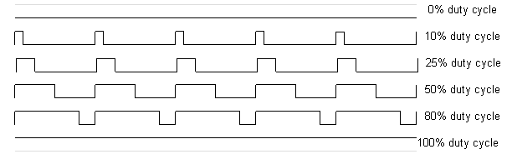

Figure PWM Wave (Arduino.cc)

Arduino UNO contains also 6 analoge pins. Analoge pins works the same as digital pins. It is used to to have varaince of value between 0 to 1, which is infinte numbers. Analoge pins can take any values between 0-1023, also it can work on inputs value from 0 to 255.

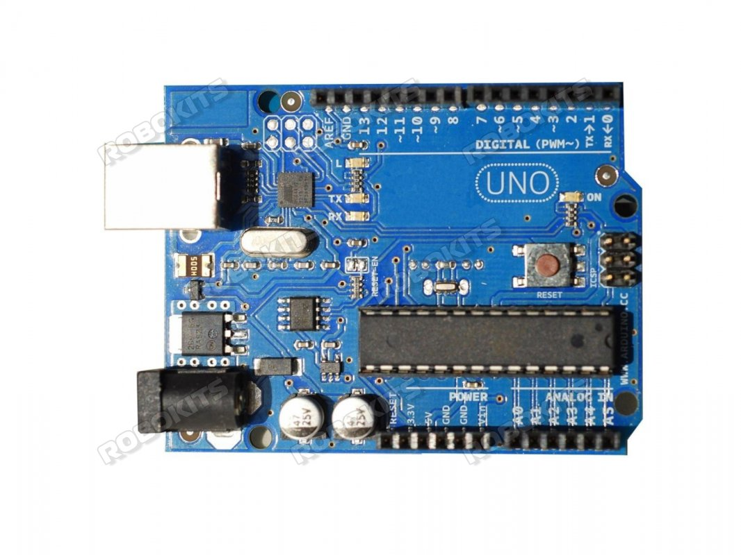

Digital pins from

0 to 13

USB connector

Power port

TX, RX LEDS

Power LED

Switch button

Volt regulator

Microcontroller

Analog Pins from

A0 – A5

Figure Ardiuno UNO

+5 v, +3.3V, ground, Vin

1. **MPU6050**

MPU 6050 is electrical component that measure 6 DOF (3-axis accelerometer& 3-aix gyroscope) and tempurature all these in one single chip, MPU contains Digital Motion Processor (DMP).

DMP software proccesses measurers 6-axis motion using algorithms. MPU can be connected to external sensor through ports (XDA, XCL). This connection in esbalished through I2C bus interferance.

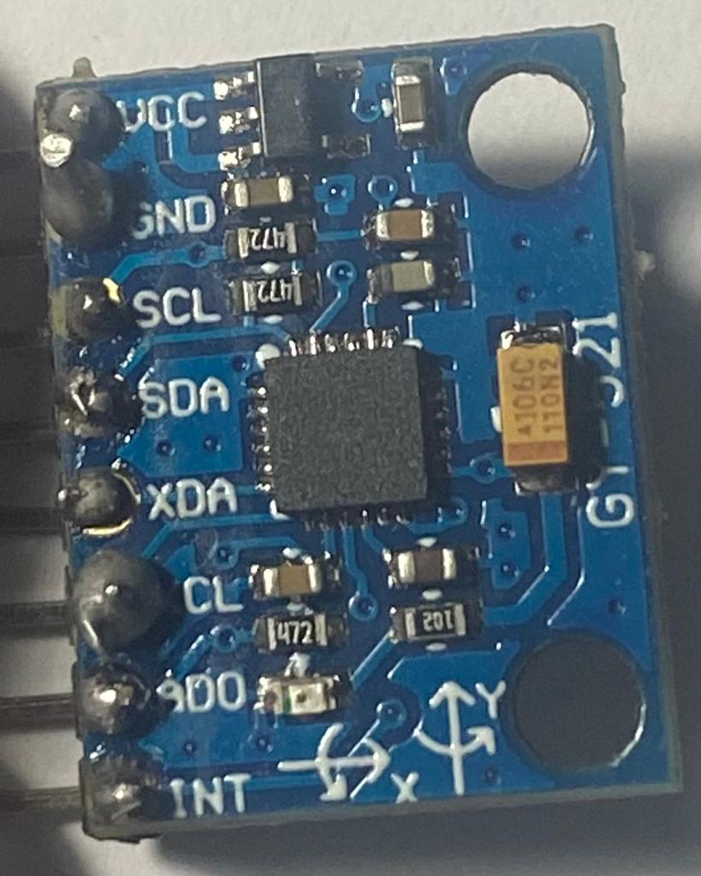

+5volt

Ground

Serial Clock /I2C

Serial Data

Auxiliary Serial Data

Auxiliary Serial Clock

I2C Address Select

Interrupt

Figure MPU6050 (6DOF)

1. **H-bridge (Motor driver)**

H-bridge is an electric componante that controlles the motor. It switches the polarity of volt wish is applied to the motor. DC motor have two terminals, which any one of them is positive and the other is negative. H-bridge switch the polarity of both terminals,which allows the motor even to move forward or backward without even changing the termianls of the motor.

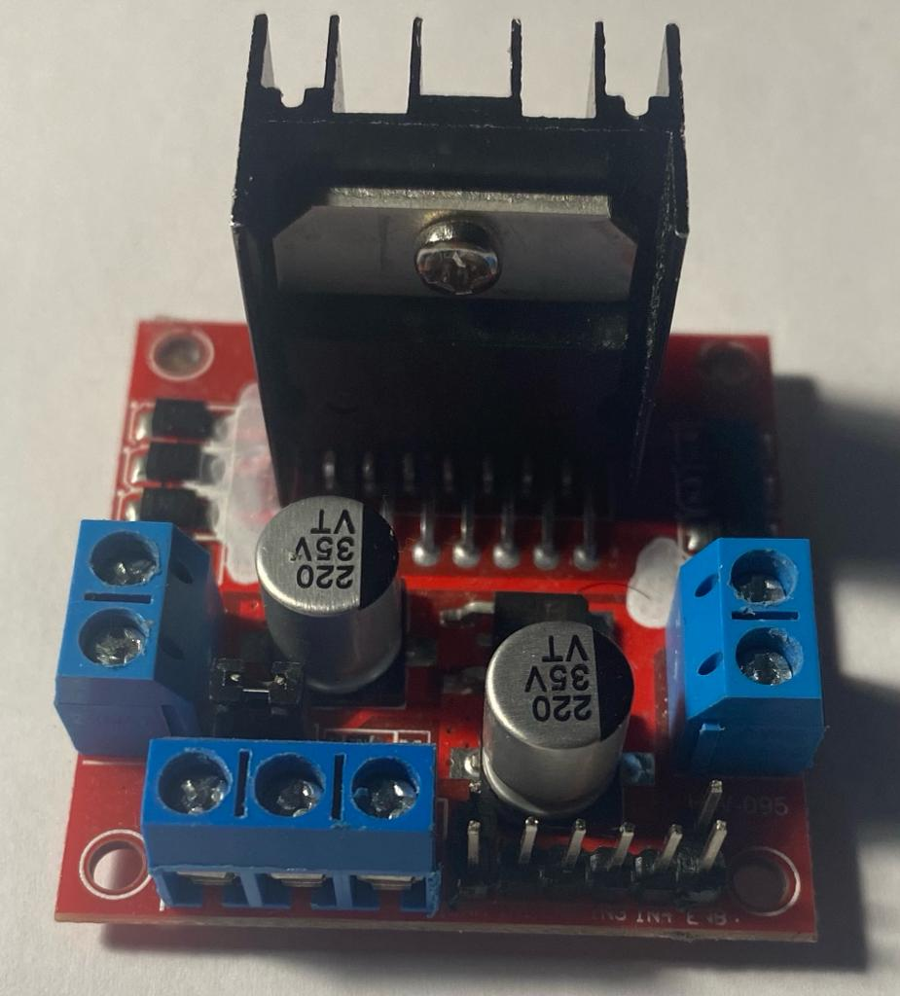

Motor B OUTPUT

Motor A OUTPUT

Motor A

ENB speed

EN3 rotation

EN4 rotation

+12volt

Motor A

ENA speed

EN1 rotation

EN2 rotation

+5volt

Ground

Figure H-bridge

* **H-Bridge Connection**

|  |  |
| --- | --- |
| **Pin Name** | **Connection** |
| IN1 & IN2 | Motor A input pins. Used to control the spinning direction of Motor A |
| IN3 & IN4 | Motor B input pins. Used to control the spinning direction of Motor B |
| ENA | PWM signal for Motor A |
| ENB | PWM signal for Motor B |
| OUT1 & OUT2 | Output pins of Motor A |
| OUT3 & OUT4 | Output pins of Motor B |
| 12V | 12V input from DC power Source |
| 5V | Supplies power for the switching logic circuitry inside L298N IC |
| GND | Ground |

**DC Motors (12 volt)**

DC 12 volt motor are also known as Battery operated (BO) motors. BO motors are geared motor which have a good weight to torque ratio. This motor with maximum current can give torque up to 800 gf.cm.

Bo motors are capable to work with or without lubrication.

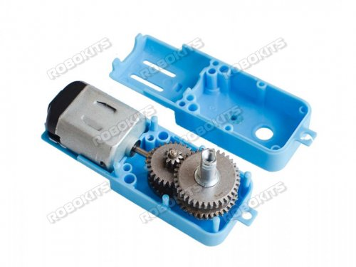

Figure 7ref 4- DC gear motor

5. Ultra sonic sensor

ultrasonic Sensor is an electric component used to measure distance using sound waves. Ultra sonic sensor have two transducers. The first one sends sound wave and called trigger, and the second one received the sound wave after hitting an object and called echo.

Ultrasonic sensor working mechanism is to send wave of frequency above human hearing range. This ultrasonic sensor have two transducers unlike other who have one transducer which do both sending and receiving. The sensor measure the distance by measuring the time taken between sending and receiving the pulse.

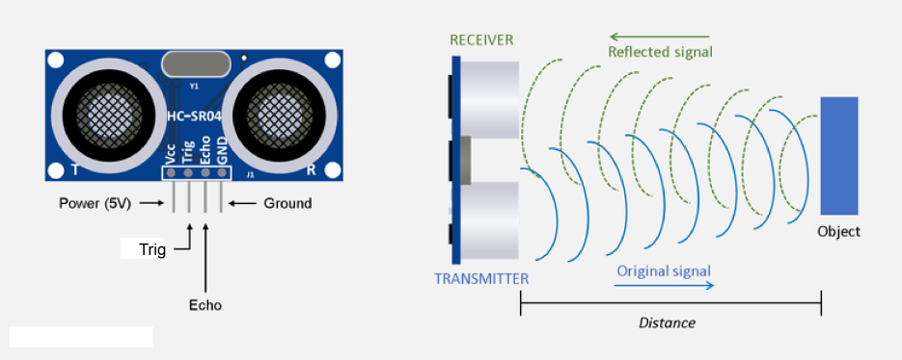

Figure Ref 4- Ultrasonic sensor

* **Speed of sound at room tempurature is approximite 29.1us/cm.**

6. Bluetooth module HC-05

Bluetooth module is a device used to communicate devices together. It is widely used now days in every single application. HC-05 have a range of 100 meters connection depending on the atmosphere and geographic. The Bluetooth module can communicate with microcontroller using serial port.

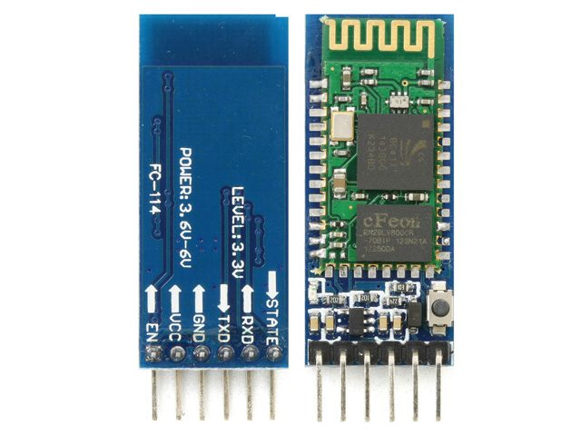7. Power Supply

Figure 9 Ref 4- HC-05

This robot is power by two separate power supplies. 9-volt alkaline battery to power up the Arduino and 12-volt lithium ion battery to power the dc motors.

7.1 9-volt Alkaline

The 9-volt Alkaline battery produces 300 mAh which is enough to power up the Arduino. It is connected using male plug port.



Figure ref 4 9Volt Alkaline battery

7.2 12 volt lithium ion rechargeable battery (18650)

The DC motor are powered with much stronger batteries. The Li-ion batteries comes with 3.7 volt and varies current mAh starting from (1500-3500).

Li-ion batteries are connected in series to produce 3.7 X 3 =12 volt.

Output ampere is 1500 mAh

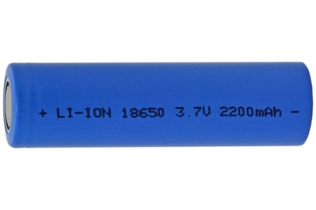

Figure Ref 4 - Lithiom ion rechargable battery

8 Frame of the robot

Self-balance robot does not focus on only electric components as such as mechanical design. Robot should be light as possible, so that the robot could keep balancing easily. The frame was built from PCB board, which is very rigid and very light. The board dimensions are 14 X 9 cm. robots levels are connected together using 10 cm threaded nail and bolts.

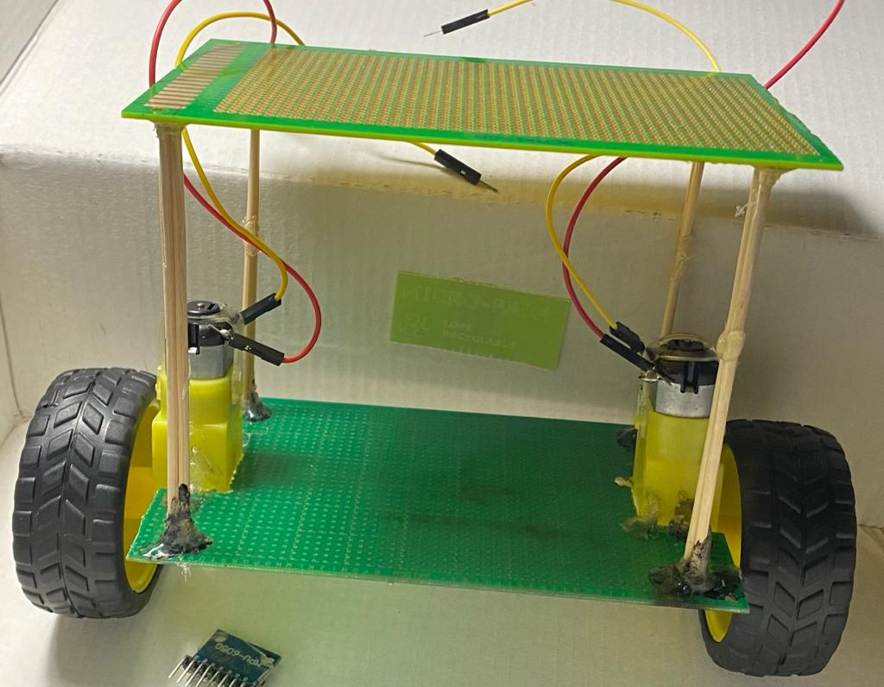

Figure robot frame

* Mechanical drawing

1 Arduino Uno

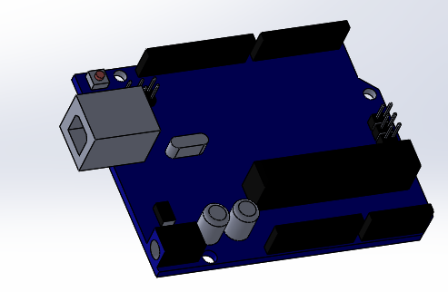

2 MPU 6050

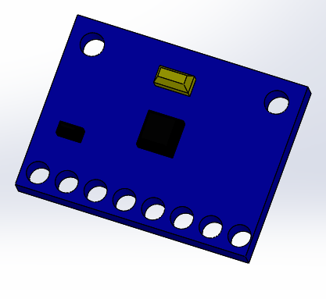

3. H-Bridge

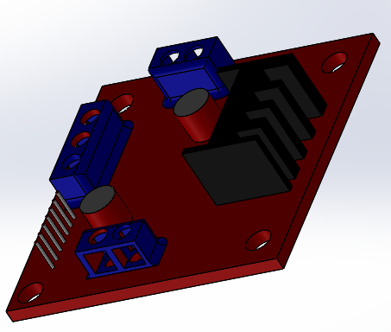

4. Bluetooth Module HC-05

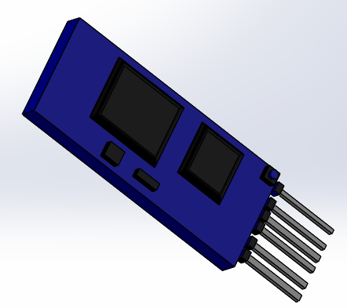

5. Ultrasonic Sensor

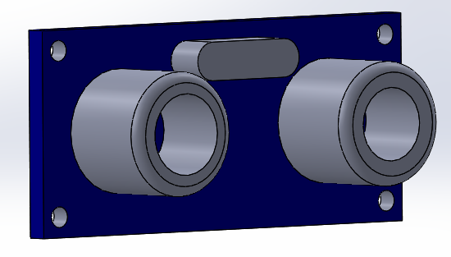

6. DC gear Motor

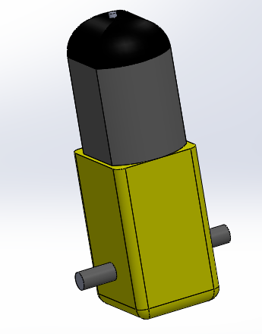

7. Power source

7.1 9 volt

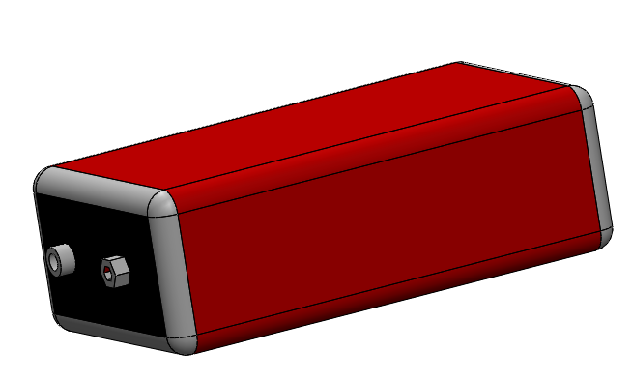

7.2 Lithium ion battery

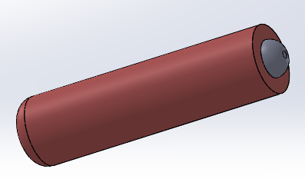

8. Frame of the robot

8.1 Lower Frame

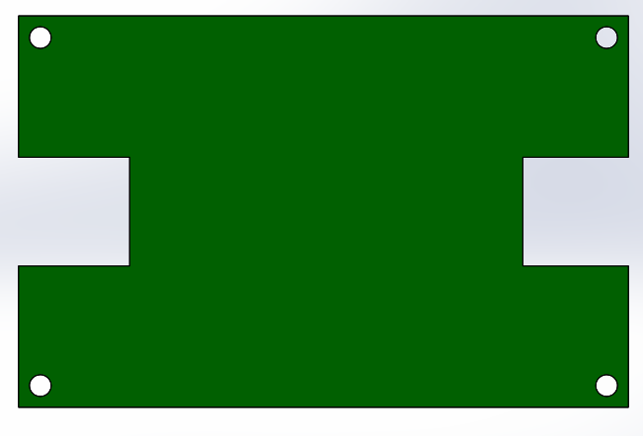

8.2 Upper frame

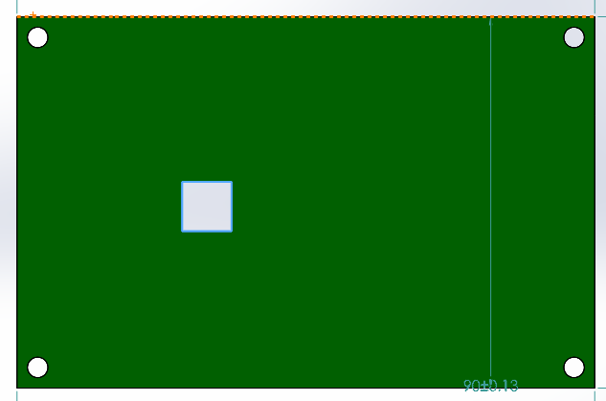

8.3 Connection

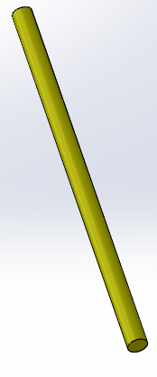

8.4 Final Frame assembly

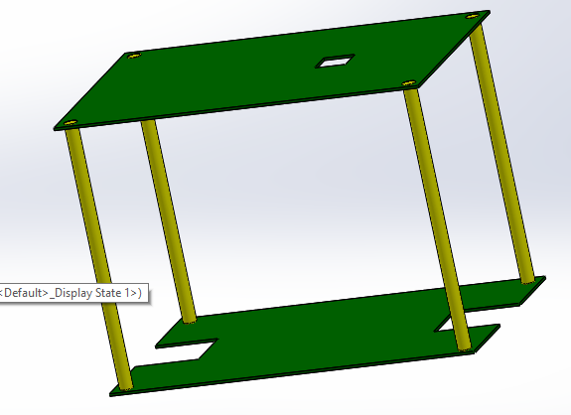

* Electrical Drawing for Self balancing robot

1. Self balance circuit

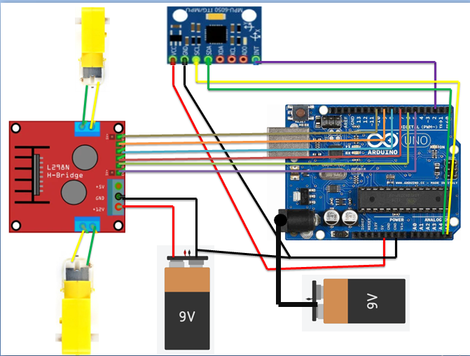

2. Ultrasonic Sensor using Bluetooth Module

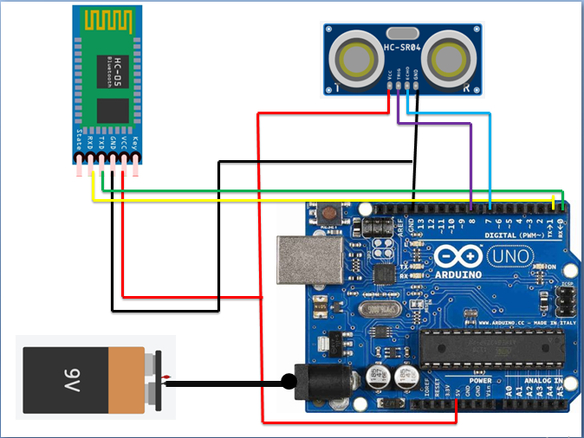

3. Merge Self-balancing robot

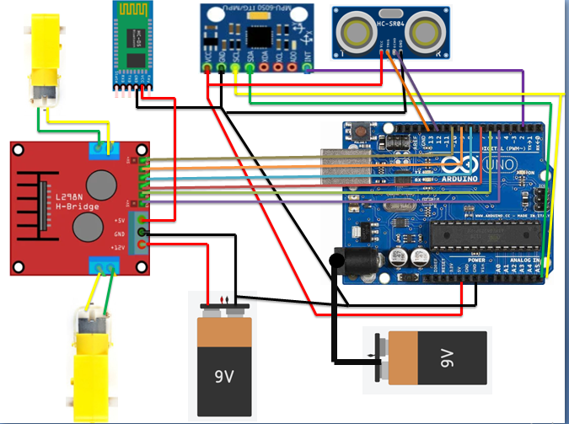

5. Block Diagram

Wheel

Surface

Sensor

Microcontroller

Motor

Balancing

Motor Driver

5.1 Flow chart diagram

False

Move Motor backward or forward

PID

If

Set point= original Point

Data from microcontroller

Data from MPU6050

True

Stop motors

5.3 Direction Flow chart

True

Flase

Move Backwords

Move Forward

If

Set point> original Point

If

Set point= original Point

False

* Structure analysis

|  |  |
| --- | --- |
| Component | Weight (grams) |
| Arduino battery | 30 |
| Arduino UNO | 25 |
| Upper Board | 25 |
| MPU 6050 | 20 |
| Nails and bolts | 50X4=200 |
| **Total Weight of upper level** | **300 gram** |
| H-Bridge | 35 |
| Motor Batteries | (35X3)+10 = 115 |
| Lower Board | 28 |
| Switch Button | 10 |
| Bluetooth Module | 20 |
| Wires | 60 |
| **Total Weight of lower Level** | **268gram** |
| **Total weight** | **568 gram** |

* Assumptions

1. Neglect weight of motors and wheels
2. Weight is equal distributed
3. Weight acts at the Mid-point of the Robot. at 7.5 cm from both motors

Maximum Torque Applied by each Motor is 800gm.cm

Maximum Torque Applied by both Motor is 1600gm.cm

Assume weight Unknown

Wth X 7.5 <= (800X2) X 7.5

Wth< = = 1600 gram

Since Actual, weight is less than the theoretical weight,

Motors can overcome the weight force and achieve balance

* Free Body Diagram

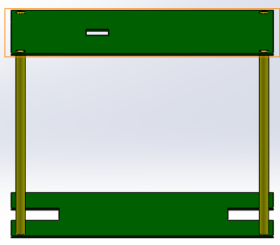

800gm.cm

800gm.cm

7.5 cm

7.5 cm

* Simulations Results

1- H-bridge controlling motor direction and speed

1.1. Circuit

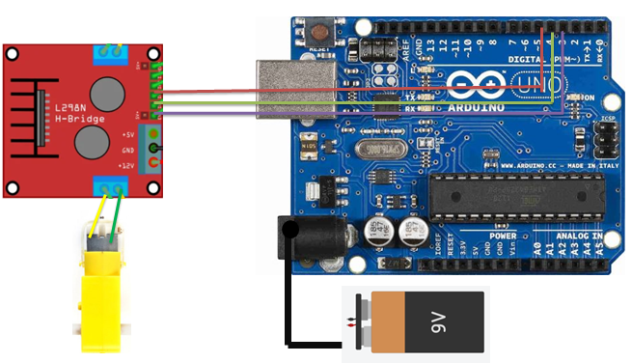

1.2. Code

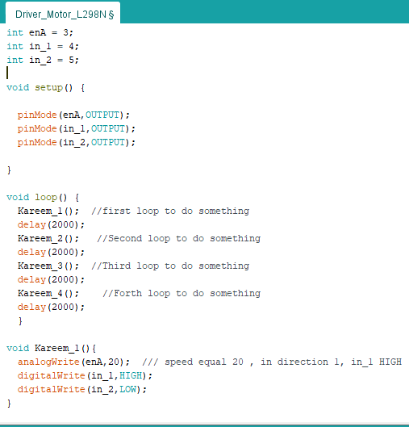

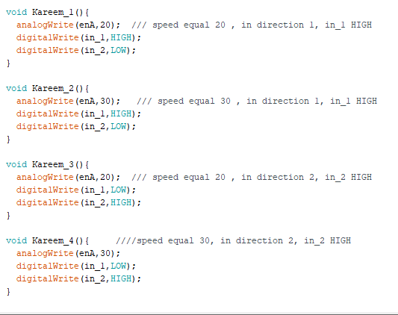

2. Ultrasonic and Bluetooth Module to send distance on mobile

2.1 Circuit



2.2 Code

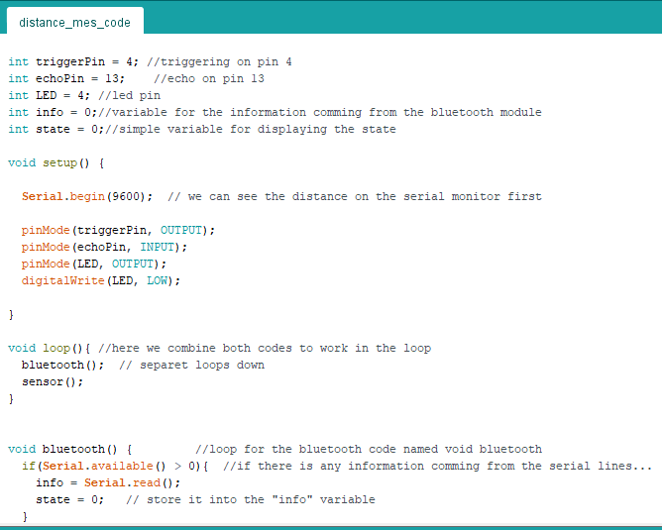

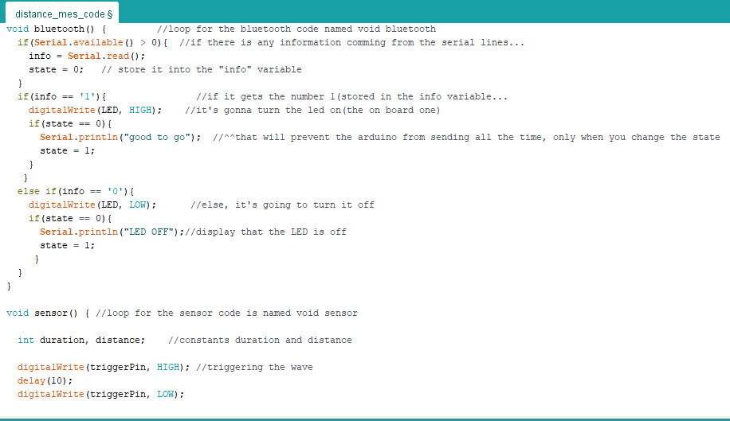

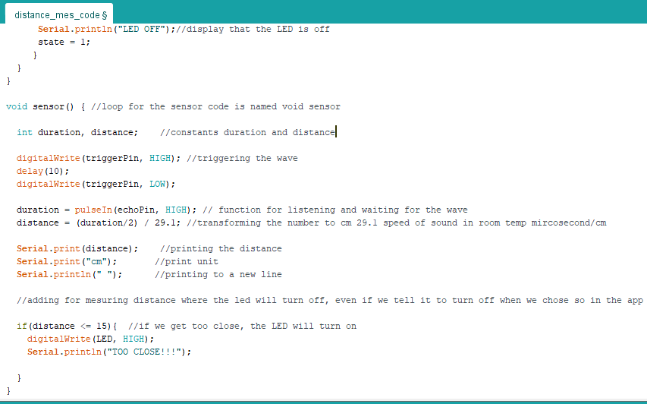

3 MPU 6050 Offset calibration

3.1 Circuit

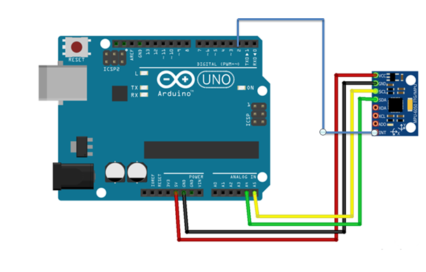

3.2 Code

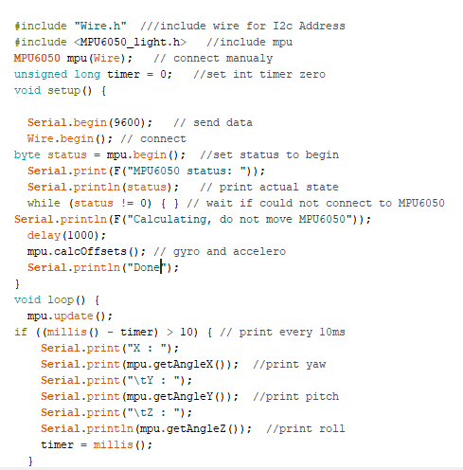

4. Self balance robot

4.1 Circuit Diagram



4.2 Code

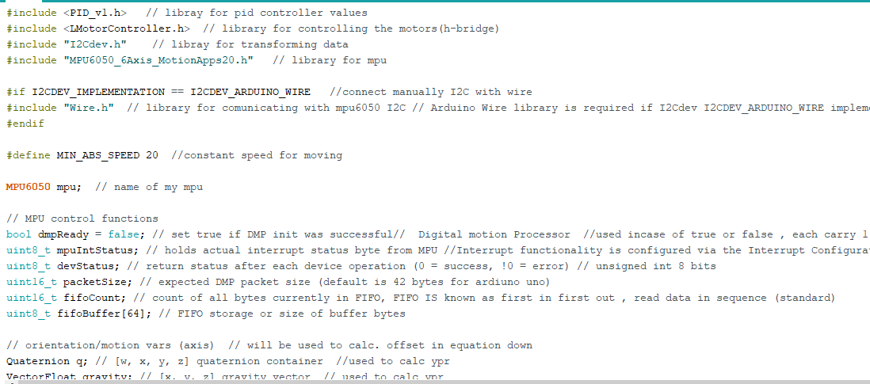

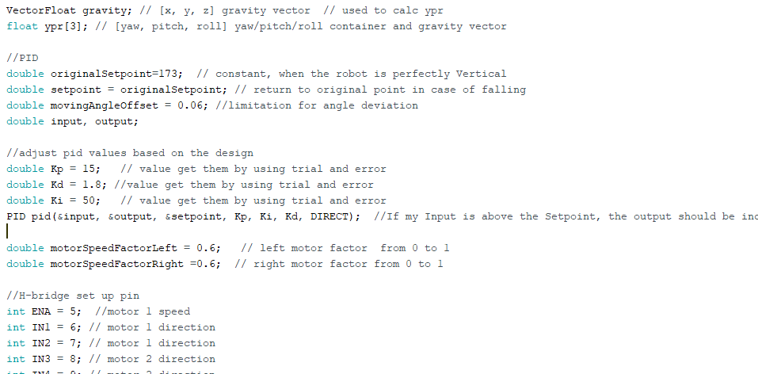

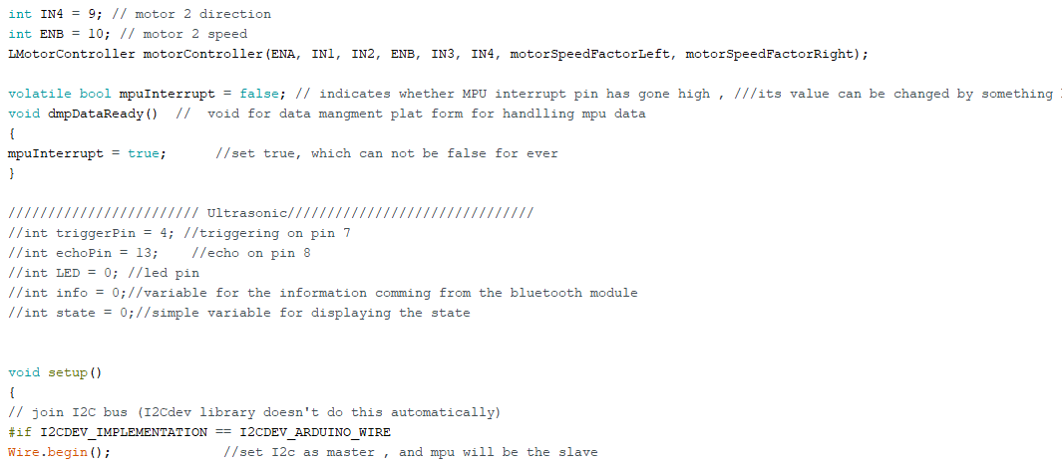

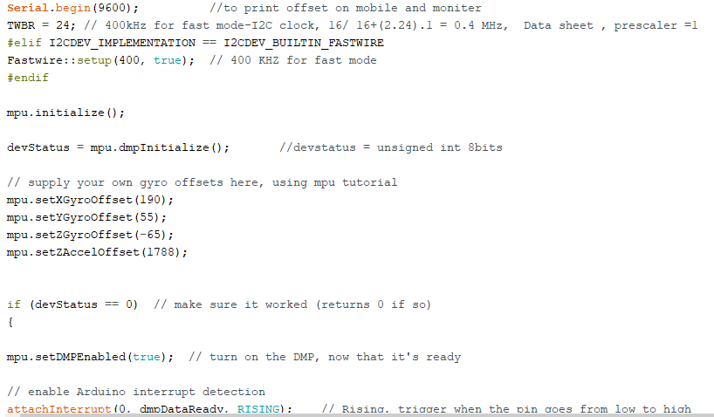

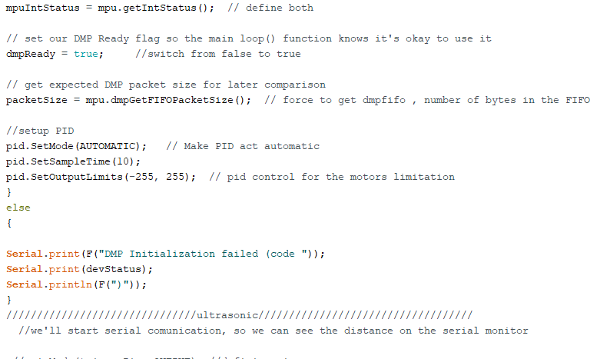

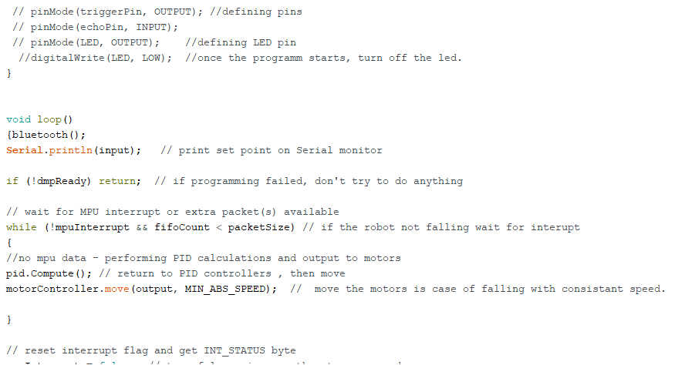

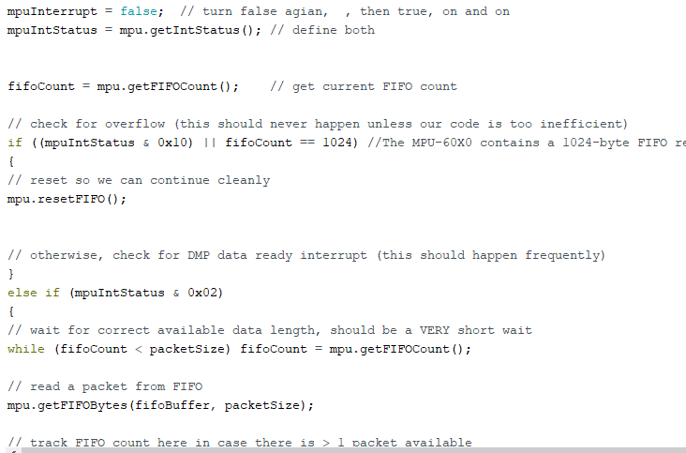

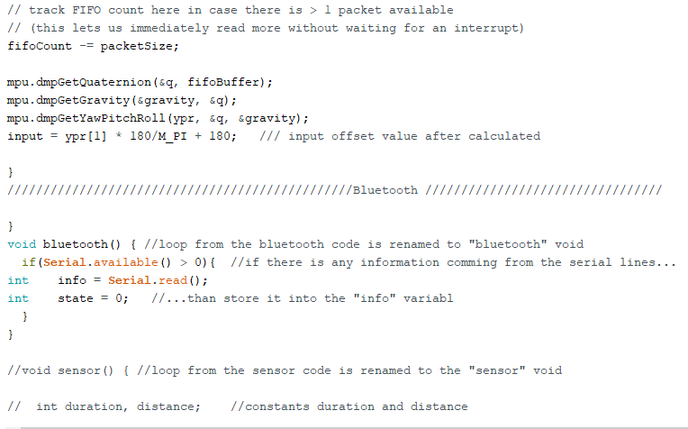

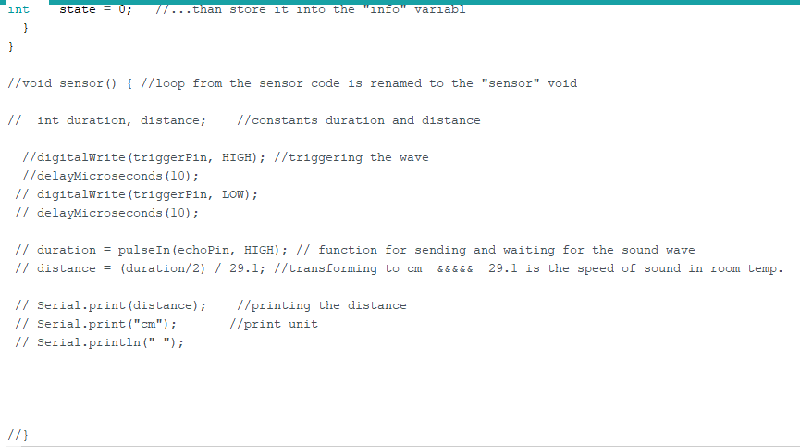

* Datasheet for self-balance

Mpu6050

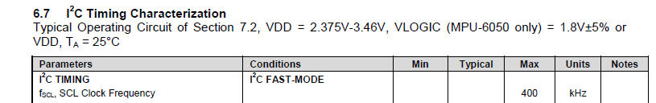

Figure Ref1. I2C fast mode frequency 400KHZ

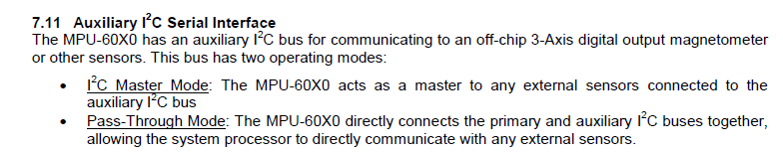

Figure 14 Ref 1. I2C modes

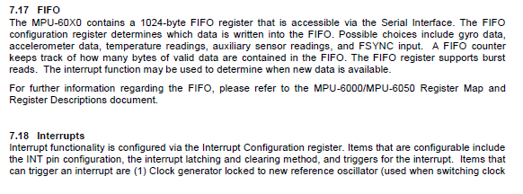

Figure Ref1. FIFO maximum bytes 1024

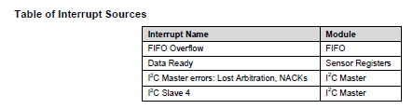

Figure Ref1. Interupt states of mpu6050

# Reference

1- InvenSense Inc. (n.d.). MPU-6050 Product Specification. TDK | Attracting Tomorrow.

<https://invensense.tdk.com/wp-content/uploads/2015/02/MPU-6000-Datasheet1.pdf>

(n.d.). TDK |

2- Franklin et al. [1998], Franklin et al. [1991], Ogata [2002], Golnaraghi and Kuo [2010], Goodwin et al. [2000]

And Astrom and Murray [2008].

# 4- <https://ram-e-shop.com/>

# 5- <https://store.fut-electronics.com/>

# 